Department | FED
subject | DSA-2
Academic | I-III Semester (2025-26)
Faculty Name | Balaiah Gudipudi
Student Name | K. Aasritha
Roll Number | 2520030178
Branch | CSE
Course Outcome | 2

Case Study Topic: Retweet Reach Prediction Using Bounded Breadth-First Search (BFS) in Twitter Follower Graphs
Work Done Summary: This case study used Bounded BFS (depth ≤ 3) to predict tweet reach in a Twitter follower graph. The traversal started from the source user and identified all reachable users within three hops. A visited set was used to prevent duplicate visits and double-counting of users reached through multiple paths. The BFS execution and implementation were verified for correctness and efficiency. Additionally, a capacity analysis was performed to evaluate whether the approach could meet the 500 m s processing budget for large-scale reach prediction.
Implementation Details :
- Represented the Twitter follower network as a directed graph using adjacency lists.
- Implemented Breadth-First Search (BFS) starting from user A with a maximum depth of 3 hops.
- Used a queue to process user s level by level and maintain traversal order.
- Maintained a visited set to avoid revisiting users and prevent duplicate counting.
- Tracked each user's depth and predecessor during traversal.
- Counted all unique users reached within the depth limit to estimate tweet reach.
- Ensured efficient execution with a time complexity of O (V + E) for the visited portion of the graph.
Result: Screenshots / Output :
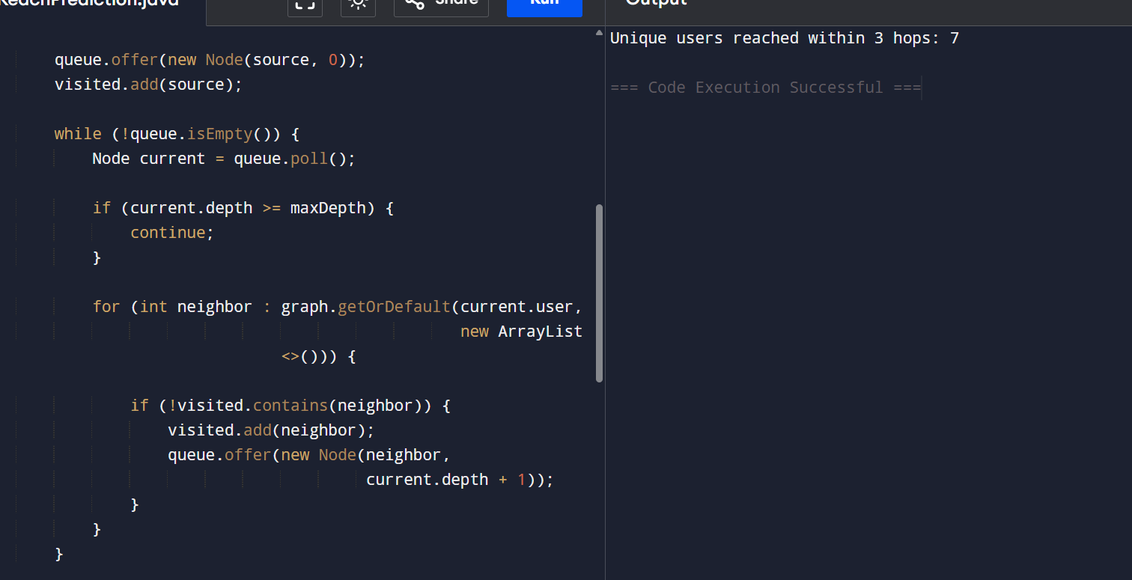
Time Complexity:
Time Complexity: O(V + E)
Where:
- V = Number of users visited
- E = Number of follower connections explored
Since each user and connection is processed only once using the visited set, the BFS traversal runs efficiently in O(V + E) time.
GitHub Link:
